Genio Notes User Guide

Accessing Genio Software

- Students receive a Genio invitation email from hello@genio.co with a link to get started.
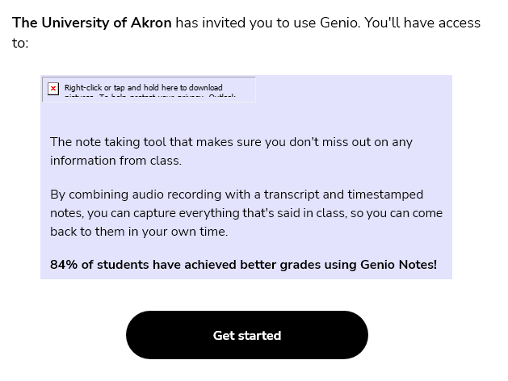

- After selecting the Get started link from the Genio invitation email, students will be prompted to create a Genio account using their UAkron email.
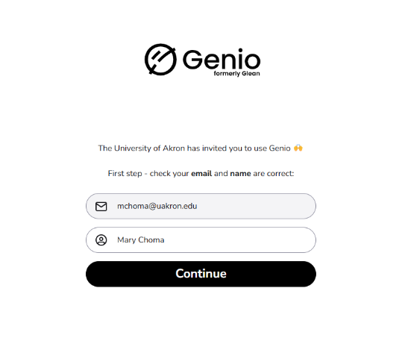

- After signing in, there is an introduction video to teach students how to use the software.

Using Genio Notes

- To begin taking notes, click the new event button in the middle of the screen. 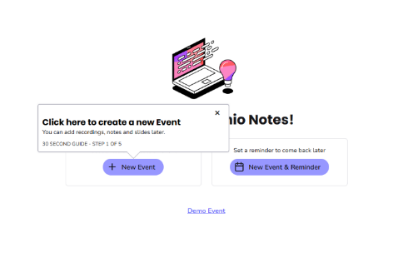

- For in-person lectures, select the microphone button at the top left to begin capturing audio. For online lectures, select the drop-down below the microphone and select record screen audio. 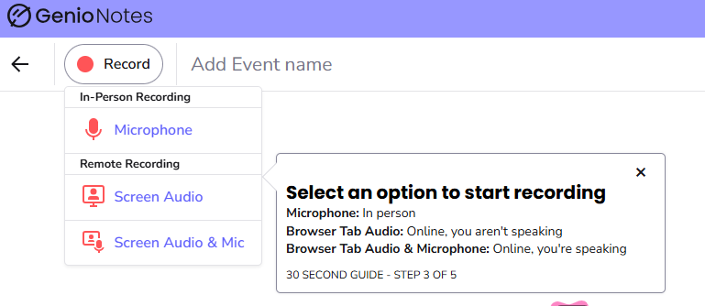

- You may be prompted with a pop-up browser extension asking for consent to use your microphone. Click Allow to continue with audio recording.
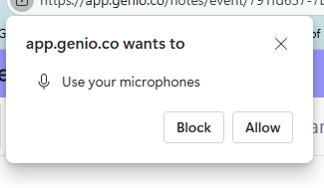

- To stop recording, select the black square, stop button, at the top left of the screen. Make sure to add an Event Name so it is clear what material this recording covers.
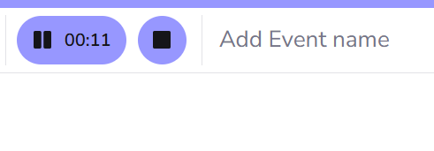

Genio Tips

- Audio can be transcribed by selecting transcript, and the transcribe audio button. Once the transcription is complete, notes can be reviewed and labels added to access important content.
- An outline can be created from the transcript, but the transcript must contain 70 words for the outline to be generated.
- Audio recordings can be supplemented with additional class materials, such as class handouts or PowerPoints, to enhance notes and fill in any gaps. These materials can be uploaded directly into the program, and they will be automatically incorporated into the generated outline of notes.
- After class, Genio notes can be added to collections to organize notes by courses.

